British National Railway Museum
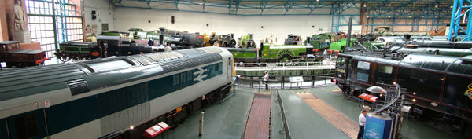
Panoramic view of the hall with the crossroads.
This museum is in York. It shelters an important collection of more than a hundred of engines and other rail equipments. The museum also includes a centre of important rail archives. The National Railway Museum (NRM) forming part of the British National Museum of Science and Industry. The NRM in York displays a collection of over 100 locomotives and nearly 200 other items of rolling stock, virtually all of which either ran on the railways of Great Britain or were built there. The NRM was established on its present site, the former York North locomotive depot, in 1975, when it took over the former British Railways collection located in Clapham and the York Railway Museum since then, the collection has continued to grow.
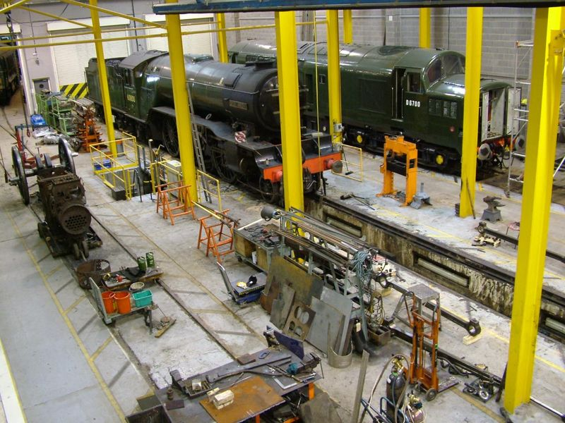

View of the workshop

National Collection
There are approximately 280 rail vehicles in the National Collection, with around 100 being at York. The first are vehicles wagonway about 1815. Permanent shop window includes " Palaces on Wheels ", a collection of Royal living rooms of Train of the first trains of queen Victoria those used by the Queen The museum has imported several important vehicles for upstairs. The museum is also the repository for a large collection of mechanical engineering drawings from railway workshops and for official photographs.
The museum was opened by Prince Philip, Duke of Edinburgh in 1975. The opening coincided with the 150th anniversary celebrations of the opening of the Stockton & Darlington Railway, for which several working exhibits were provided.

QUIZZ:
1. Where is the museum?
2. What's the sigification of NRM ?
3. How much of locomotives there is?
4. How much of other rolling stock ?
5.

