Liverpool: The Docks

The Docks were of use for the trade of the good.Today, the docks have taken on a very different role, redevelopment and restauration, in the early eighties, have established the Albert Docks as one of the Country's largest tourist attractions.The redevelopment of the Albert Docks has brought with it investment in shops, pubs, cafe-bars.To begin with this job was not-full-time and the job-title has changed many times over the years.After 1913 the job of dock engineer at Liverpool was more to do with looking after the port's existing docks rather than building new one.
Albert Dock
In 1845 (the first Dock) Albert Dock opened.

Quizz

- For what were of use Docks ?
- Today what is Docks's roles?
- When did the first Docks opened ?
- Why they build new Docks after 1913 ?
- Which was build the first Docks ?

Befor the restauration After the restauration
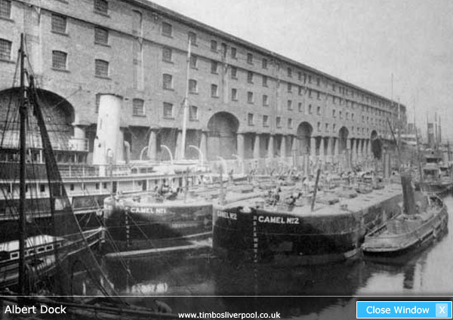
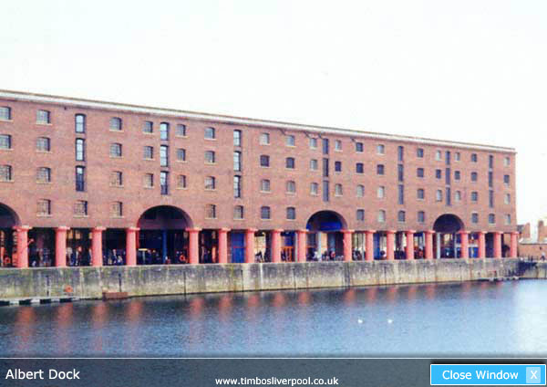
Befor the restauration After the restauration
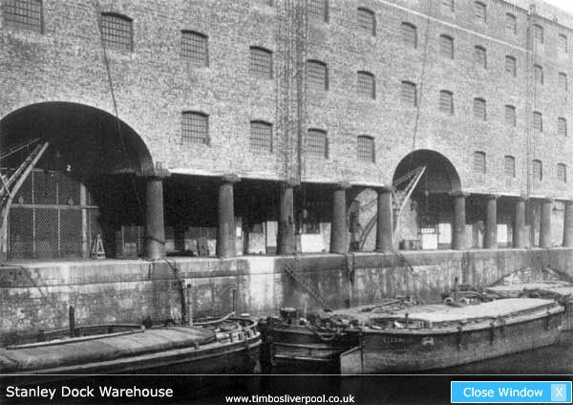
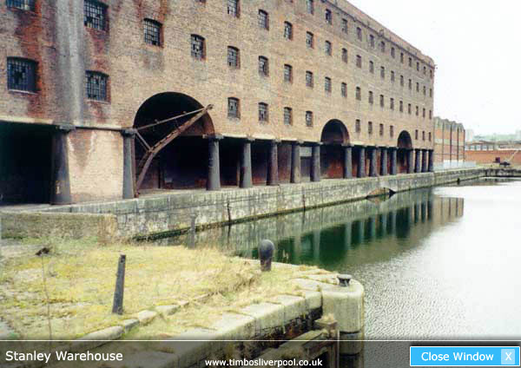

Tissot Juliette et Bécue—Roydor Marion4° europe

