Merseyside Maritime Museum
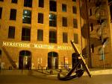
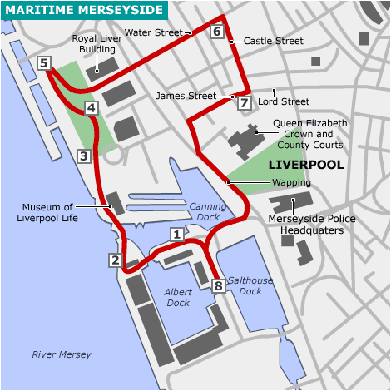
Liverpool lies to the west coast of England, in merseyside.The Merseyside maritime museum is located on Albert Dock, just next to the street Hartley quay, located at the west of the city.
The Merseyside Maritime Museum tells the history of one of the world's greatest ports. Discover Liverpool's central role in centuries at sea as the gateway to the new world, how the Titanic, Lusitania and Empress of Ireland tragedies affected the city and how merchant navy ships operating out of the port have provided a lifeline in times of war and peace.
For over two hundred years Liverpool was one of the world’s greatest seaports. Today it remains Britain’s largest west coast port and continues to offer shipping services to many parts of the world.
The merseyside maritime museum tells the story of one of the largest ports and people who used it. For many, it was a gatway to new life in other counties.The museum's collections reflect the international importance of Liverpool, the city including its role in the transatlantic slave trade and emigration.The maritime archives and library contains one of the greatest collections of the merchant marine .
