CHESTER

Medieval Chester:
Chester became the largest port in the north west of England in the Medieval period.
Chester Cathedral and the city walls we see today were built in this period. It reflects (reflète) the wealth (richesse) of Chester at the time.The oldest surviving shop frontage in Britain.
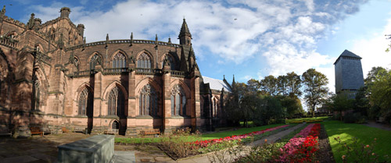
Tudor Chester:
Tudor buildings were typically constructed using English oak timbers (bois de chêne) then painted with black tar for protection from the weather (intempéries). The white paint you can see is wattle and daub (enduit) then painted with lime wash (chaux puis laver). Other Tudor characteristics include: small leaded glass windows , overhang upper floors (de faux étages) .There are many buildings in Chester that look Tudor.
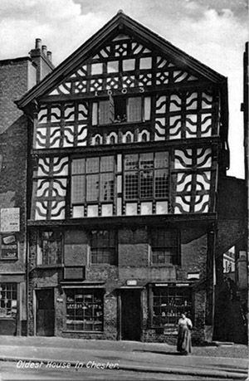
Georgian Chester:
Thomas Harrison (1744-1829)
The famous Georgian Architect who worked in Chester and the North West. trained in Rome, he then practiced for much of his life in Chester. Arguably (sans doute) the greatest architect of his day in the North West of England.
Victorian Chester:
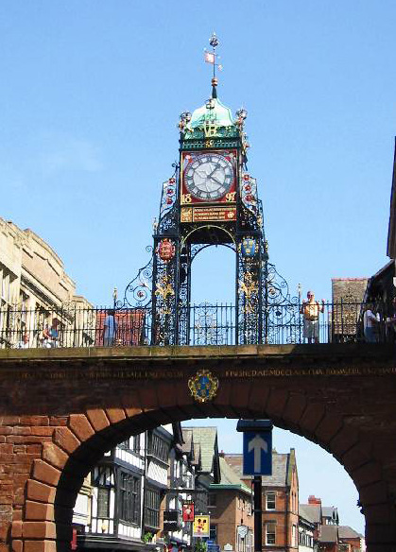
The Eastgate Clock (above) was built at the end of the 19th century to commemorate Queen Victoria's Diamond Jubilee. Originally this gate was the main entrance to Chester.

Roman Chester:
The History of Chester can be dated back to the Romans who named Chester Deva after the spirit (esprit) of the River Dee. Roman Chester was considered as important then as London. The Romans didn't just create a small fort here, they meant to stay, building a city for their 20th Legion. The Romans built Chester as a strategic position at the centre of Roman Britain, with plans to sail from the River Dee to invade (envahir) Ireland and North Wales.
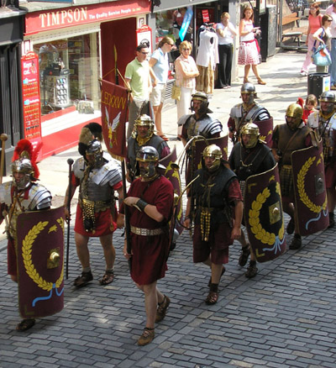
Today you can still walk along Roman roads (voies) in the centre of Chester. The Romans also built a network (réseau) of roads from the South East of Britain to Chester and on North to Hadrian's Wall.

Quizz:

- Where is the largest port in Chester? -What is a tudor building made of ?
 In the North  Fir Wood
 In the North West  Olive Timbers
 In the West  Oak Timbers

- Who was Thomas Harrison? - When was Eastgate clock built?
 A Georgian architect  In the 18th century
 An American architect  In the 19th century
 An African architect  In the 20th century

- Who built Chester?
 The Romans
 The French
 The English

Roux Antoine Et Marion Bosmorin 4°A

